A.A. Milne Elementary School 
7800 Portal Drive Houston Tx, 77071
Family Engagement Policy
Title I, Part A School-Wide 2024-2025

Purpose: A strong partnership between the school and home is essential if a quality educational program is to be provided to all students. A.A. Milne Elementary School is dedicated to the philosophy that parent involvement is integral to the success of each student. For this reason, parents are actively recruited as our partners for success. Parents will be invited to participate in the annual revision of the campus School-Family Compact, Family Engagement Policy, Campus Improvement Plan and Comprehensive Needs Assessment. An updated copy of the Family Engagement policy will be posted annually on the campus web page. Two annual meetings will be held to inform parents of the school’s participation in Title I, Part A programs and to explain the Title I, Part A requirements and the rights of parents to be involved in Title I, Part A programs. The meeting will be held at a time that is convenient for parents to attend.
Goals
- The school will work to ensure that the required school levels of parent involvement policies meet the requirements of section 1116 ESEA(Elementary and Secondary Education Act).
- The school will educate teachers, specialized instructional support personnel, principals, and other school leaders, and other staff, in the value of parental contribution and in how to communicate with parents and build school family connections.
- The school will communicate with parents in an understandable and uniform format and, to the extent practicable, in a language the parents can understand(English/Spanish). The school will use the following modes to communicate with parents:
- Take Home Folders
- Homework/conduct sheets/School Flyers/Positive notes home to parents of student success
- Parent/Teacher Conference Forms
- School Marquee o HISD Web Page
- Milne Elementary Web Page
- Milne Elementary Student Handbook
- Translators Provided
- Automated Mass Calling System Through District Schedule
- Automated call-out system (campus)
- Schoology o Parent Home Access Center Via District Web Page
- Smartphone Apps (Class Dojo)
The school and parents will work collaboratively to ensure strong family engagement, and to support a partnership among the school, parents, and the community to improve student academic achievement. The following is a list of opportunities that have been created to inform and involve parents, not limited to other reasonable support for family engagement activities as parents may request:
- Flyers/Notices Home (Outlining school curriculum, forms of academic assessment)
- Student Parent Handbook (Outlines End of Year Grade Level Expectations)
- Progress Reports and Report Cards Meet the Teacher Night – First Visit w/Child’s New Teacher in August Open House Night (Review Title I Budget/Programs)
- Workshops/Support/Resources
- Fall Festival – Held in November
- SDMC Committee Meetings
- Content Nights
- Go Texans Day –Pre-K-5th
- Sharing of school report card(open forum/campus website/school newsletter)
- Elementary Promotional Ceremony for Kinder and 5th Grade, STAAR End of Year Student/Parent Reports
- TELPAS End of Year Student/Parent Reports
- Kindergarten Round-Up (PK Visits Kindergarten Classes in May)
- Title I, Part A Annual Meeting Held in Conjunction with another Parent Event
- Dual Language Parent Nights
- Fine Arts Club (Majorette, Dance, Cheer, Gardening)
ANNUAL EVALUATION - A.A. Milne Elementary School will hold annual meetings to review the Family Engagement Policy and the School-Family Compact. The Family Engagement Policy ensures that there is a strong partnership between the school and the parent. A School Family Compact will describe school and parent responsibilities.

Parent Signature ____________________________________ Date____________________

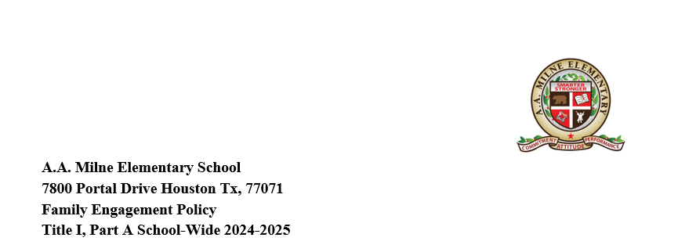Propósito:
En orden de proveer un programa educativo de calidad para todos los alumnos, es esencial mantener un lazo sólido entre la escuela y el hogar. La filosofía educativa de la Escuela Primaria A.A. Milne se basa en que la participación de los padres es esencial para el éxito de cada alumno. Por esta razón, los padres están activamente invitados como nuestros aliados para el éxito. Los padres participarán en la revisión anual del Acuerdo escuela-familia, la Política de Participación de la Familias, el Plan de Mejoramiento de la Escuela y la Evaluación Completa de las Necesidades. Anualmente se publicará una copia actualizada de la política de participación de la familia en la página web de la escuela. Se llevarán a cabo dos juntas anuales para informar a los padres de la participación de la escuela en los programas del Título I-parte A y para explicar los requisitos y derechos de los padres a participar en estos programas. La junta se llevará a cabo en un horario que sea conveniente para que los padres puedan asistir.
Objetivos;
- La escuela trabajará para asegurar que las políticas requeridas de niveles de participación de los padres en la escuela, cumplan con los requisitos de la sección 1116 de la ESEA.
- La escuela entrenará a los maestros, al personal de apoyo de instrucción especializado, directores y otros líderes escolares y demás personal, en el valor de la contribución de los padres y cómo comunicarse con los ellos y promover conexiones entre la escuela y la familia
- La escuela se comunicará con los padres en un formato comprensible y uniforme y, en la medida de lo posible, en un idioma que los padres puedan entender (Ingles y español). La escuela utilizará los siguientes modos de comunicarse con los padres:
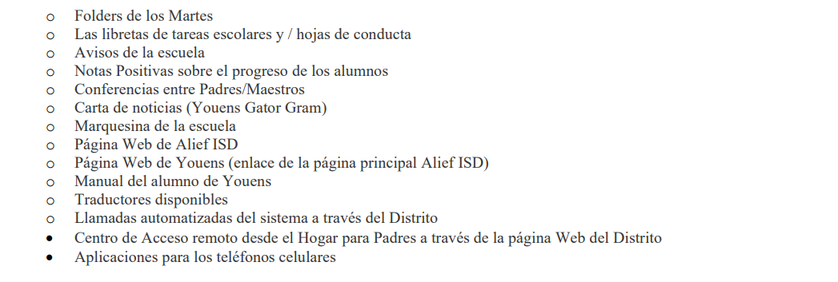
La escuela y los padres trabajarán unidos para asegurar una fuerte participación de la familia y para apoyar una alianza entre la escuela, los padres y la comunidad para impulsar el progreso académico. La siguiente es una lista de las oportunidades que se han creado para informar e involucrar a los padres, sin limitarse a que exista otro tipo de apoyo razonable para actividades de participación familiar que los padres puedan solicitar.
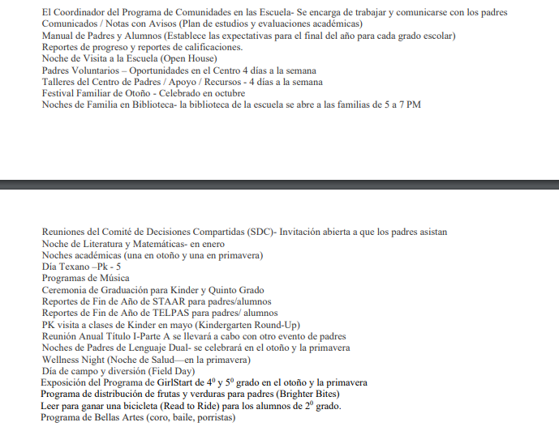

Parent Signature ____________________________________ Date____________________

